EXPERIMENT

AIM: Design a Automatic Night Lamp.

APPARATUS: one Arduino Board, one breadboard, one LED, connecting wire, resistors – 10 k Ώ, LDR (photoresistor),

CIRCUIT DIAGRAM:

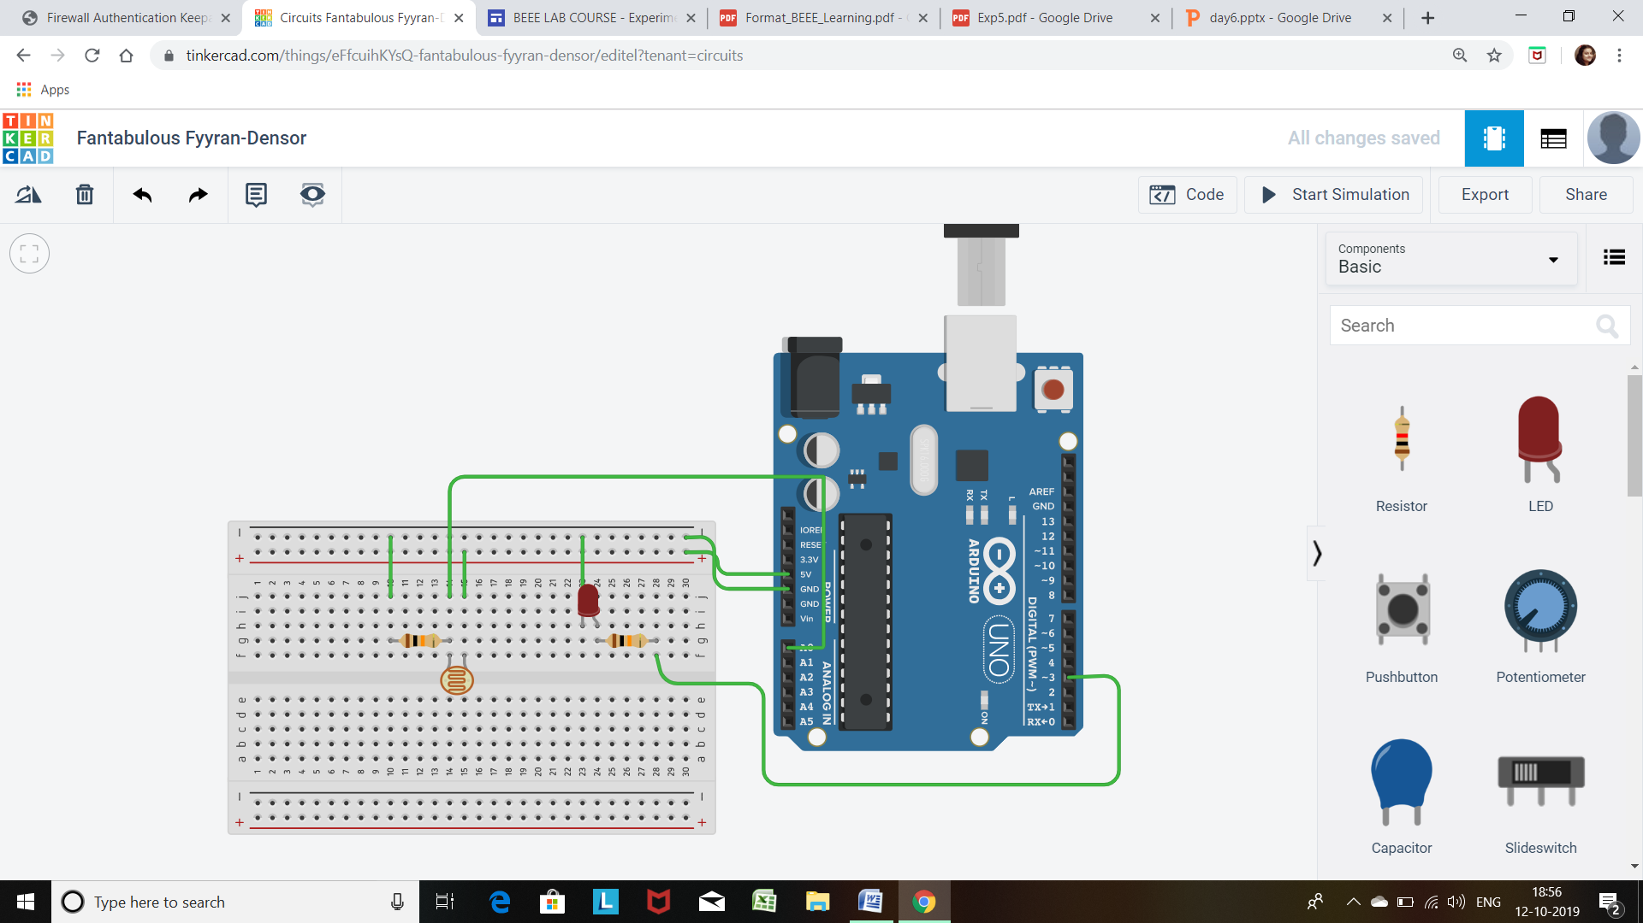

THEORY:

1. CONCEPTS USED :

* Here we used the concepts of LDR, i.e. Light Dependent Resistor.

This type of resistor is used to detect the presence as well as the absence of the light in the surrounding.

The LDR change the behavior of the circuit according the response from the surrounding.

If the intensity of the light is high, the resistance of the LDR gets decrease and if the intensity of the Low, then the resistance increase.

1. LEANING AND OBSERVATION:

* We have learned how to use the LDR and used it as desired. We have used it as to make Led light controller which get light up when there is Low light.
* Here we have also learned about the Analog pin of the Arduino board, we get to learn how the board converts the analog signals into discrete digital signal so that the computer can easily operate.

PROBLEMS AND TROUBLESHOOTING:

* Due to the wrong connection of the circuit, like the connection of the positive end of LED with the cathode terminal, the LED was not glowing.

By observing the cathode and anode terminal the connection was corrected.

* By connecting the LED directly to source, it increases the chance of destroying it. So by using correct resistor with desire resistance I ensure less damage of LED.
* And sometimes due to wrong insertion of pin in the Arduino board the LED do not glow.
* Correct calculation of the resistor connected to the LDR is necessary.
* Sometime the COM port of the Arduino creates problem. So we have checked it thoroughly for the proper connection with the computer.
* Due to intensity of the light present in the room, it was difficult to measure the correct resistance that was produces by the LDR

PRECAUTION:

1. We should avoid the direct connection of the LED to the battery or any kind of source.
2. Checking the continuity of the current flowing through the circuit.
3. Resistance of the resistor should be correctly calculated for proper reading.

LEARNING OUTCOMES

By doing this experiment we learned to control a LED automatically with continuously providing input manually.

We also learn how we can start to connect the computer to the physical surrounding.

How the software are able to sensed the physical signal and respond accordingly.

RESULT

After uploading the desired code in the Arduino, the LED start to operate automatically just by sensing the Light intensity.